WE-S503 Product Specification Document for Collar-Type Positioning Device
Product Overview
The WE-S503 Western Positioning Collar for Pastoral Herding is specifically designed for livestock tracking applications. This collar integrates BeiDou/GPS positioning with 4G communication technology. Once worn around cattle or sheep, it instantly collects real-time location data and activity metrics, transmitting information wirelessly via 4G to cloud servers for display on mobile apps or platform interfaces. Featuring dual-mode BeiDou/GPS positioning modules, the collar ensures precise positioning with low power consumption. Equipped with a 3-axis accelerometer, it tracks daily step counts during each monitoring cycle, allowing health status and estrus cycle monitoring through step pattern analysis.

Product topology

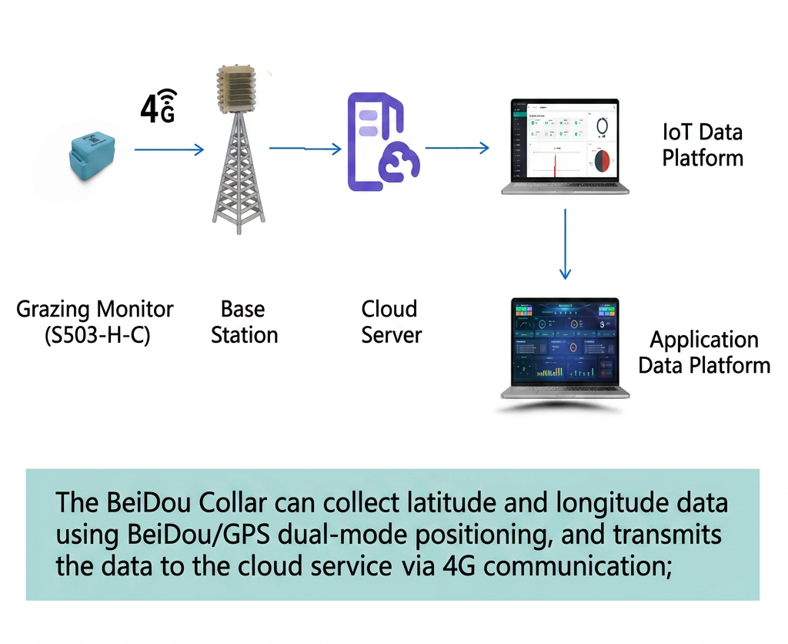

size of product

product name | Pastoral Patrol | product model | WE-S503
product appearance
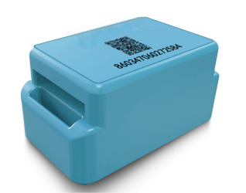
order number | class | project | Product Parameter
1 | essential parameter | communication mode | 4G
2 | essential parameter | ambient temperature | -30℃—60℃
3 | essential parameter | Upload frequency | Upload every 2 hours by default (frequency adjustable, depending on power consumption)
4 | essential parameter | cruising power | 12 months (battery replaceable)
5 | essential parameter | location mode | Beidou/GPS dual-mode positioning
6 | essential parameter | positioning accuracy | 5m–10m (Positioning accuracy is affected by weather conditions and obstructions)
7 | essential parameter | External protection rating | IP67
8 | essential parameter | size | 86mm*50mm*44mm
9 | essential parameter | Weight (excluding straps) | 189±3g
10 | product function | Livestock positioning and movement monitoring
11 | usage scenario | Location and Health Monitoring of Free-Raising Cattle, Sheep, and Camels
functional characteristics
● Precise positioning: The collar employs dual-mode GPS and Beidou positioning to accurately collect location data of grazing livestock.
● Health monitoring: The collar collects exercise data of grazing livestock, enabling the platform to assess their health status, disease conditions, and mortality based on physical activity levels.
● Superior material: The casing is made of premium engineering plastics (plastic alloys), offering strength, toughness, and environmental friendliness.
● Extended battery life: Equipped with high-capacity, high-density non-rechargeable lithium batteries and ultra-low power consumption design for prolonged operation.
● Compact size and lightweight design: Easy to wear with a weight of approximately 189g, causing no stress response in livestock.
● One-click inventory: By screening the real-time online status of collars, it enables rapid identification of livestock wearing collars, preventing loss or accidents.
● Epidemic surveillance: Through comprehensive analysis of livestock movement patterns, abnormal animals are rapidly identified and alerts are generated via the platform to achieve early epidemic warning and prevent large-scale transmission of diseases.
● Estrus monitoring: By comprehensively analyzing the physical activity of livestock, estrus animals can be rapidly identified and alerts generated through the platform to achieve estrus early warning, thereby preventing missed estrus periods.
● Location monitoring: Implement location management for each livestock unit, equipped with electronic fences, and trigger immediate alarms upon departure to prevent livestock loss.
● Convenient remote management: User-friendly WEB/App interface for remote farm management, offering simplified and efficient operations
Service Overview and Architecture
The positioning collar-Muxun (WE-S503) management IoT service is centered around an intelligent centralized network management platform for remote centralized management of smart collars. Based on a browser/server (B/S) architecture, users can remotely monitor, configure, and manage devices via web browsers, offering user-friendly operation and significantly reducing equipment management costs.
The positioning collar-Muxun (WE-S503) is built on an intelligent centralized network management platform as its core IoT service management system, featuring the following architecture:
Hardware device: Location collar.
System software: web-based management systems, mini-programs, etc.
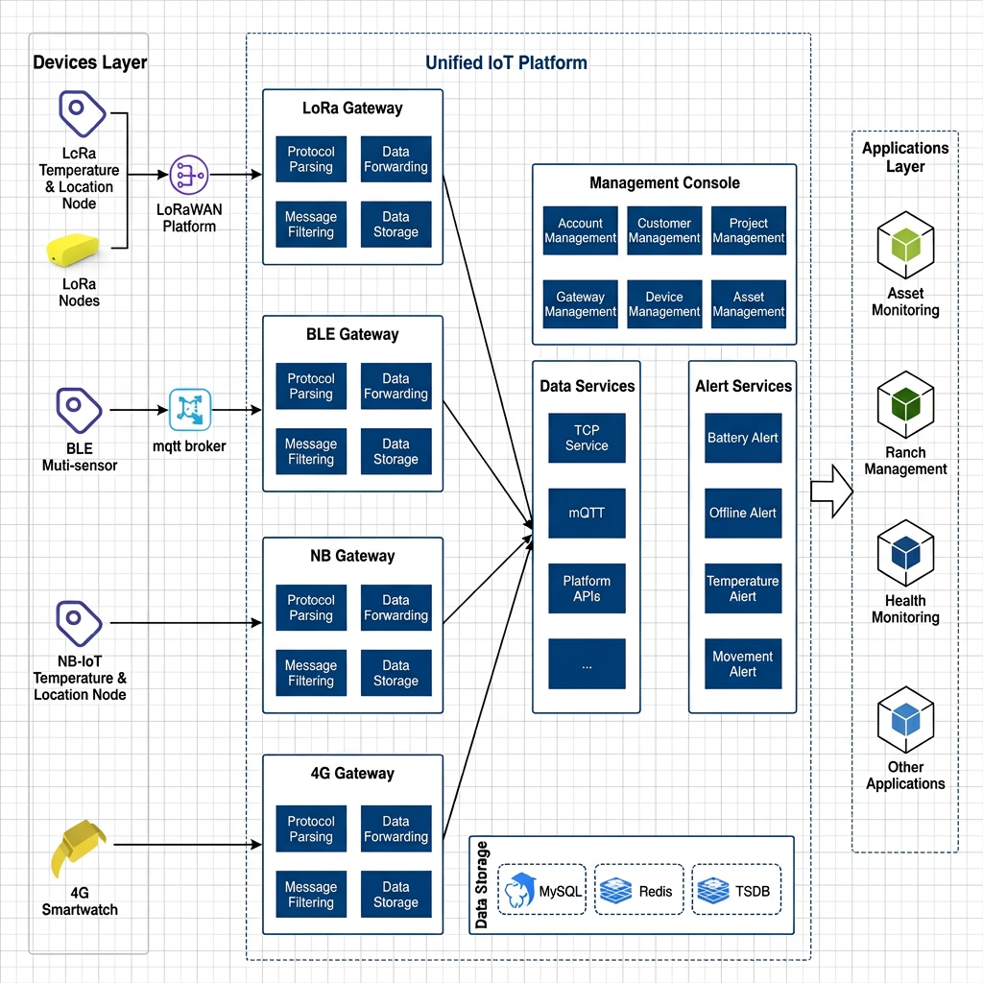

Data integration
Zhongnong offers three data integration solutions to accommodate diverse client requirements.
Method 1: Subscribe to MQTT
Method 2: WEBHOOK
Method 3: Interface Integration
For detailed docking methods, please refer to the WEST Smart Terminal Docking Documentation.

