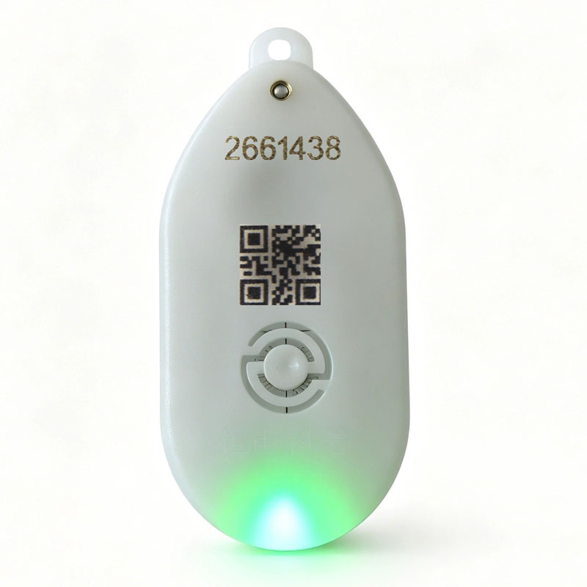
I. Product Overview
The WE-T01 Active Acoustic-Optical Electronic Tag is a powerful smart device with a wide range of application scenarios, designed to provide efficient positioning and retrieval solutions for managing various items. This tag periodically broadcasts its tag ID information via wireless signals; in open environments, the maximum transmission distance can reach up to 100 meters. When paired with a positioning base station (system), it enables precise positioning; even without a dedicated positioning system, the tag can be easily located using only a handheld device.
It is equipped with one high-brightness LED light and one 85 dB buzzer; upon receiving a call command, it emits both a conspicuous light and a loud sound, facilitating the rapid localization of target items and enabling their identification—then, by pressing the confirmation button, the call can be terminated. By securing this device to various objects such as transport boxes, carts, or workpieces, it allows for easy location of these items regardless of where they are being transported.
Additionally, the accompanying Warehouse Management System supports use on computers, handheld devices, or mobile phones, enabling efficient inventory counting and item calling within the warehouse, effectively preventing item loss and significantly enhancing warehouse management efficiency. The electronic tags are powered by a CR2450 button battery, offering long battery life and intelligent power management capabilities, thereby meeting the requirements of various application scenarios.

II. Product Features
1. Eye-catching audio-visual alert: Equipped with one high-brightness LED bead and one 85 dB buzzer; when a call command is received, it will emit both a conspicuous light and a loud sound, ensuring that attention is drawn in all environments.
2. Ultra-long firing cycle: A single CR2450 button battery can support up to 19 million firings; furthermore, the battery is replaceable, ensuring long-term stable operation of the device.
3. Mechanical confirmation button: Features a physical mechanical button; pressing it once will stop the audible and visual alerts and report the button press event.
4. Long-duration audio-visual functionality: The cumulative duration of audio-visual alerts shall be no less than 20 hours (excluding power consumption associated with wireless transmission), meeting the usage requirements for frequently locating items.
5. Smart Battery Management: Equipped with under-voltage alerts and real-time battery level display; even after an under-voltage condition occurs, the remaining battery power can still enable 1 million transmissions, allowing users to stay informed about their battery status and plan their usage accordingly.
6. High-efficiency wireless transmission: The wireless transmission power is 3 mW, with a transmission range of up to 100 meters; simultaneously, the standby power consumption is only 2 μA, effectively reducing energy consumption while ensuring adequate signal transmission range.
7. Free Open Frequency Band: Utilizes the 2.4 GHz global open microwave frequency band; no application or payment is required, making deployment and usage straightforward.
8. Flexible installation options: Supports multiple installation methods—including keychain clip attachment and 3M adhesive mounting—allowing users to choose the most suitable method based on the object and scenario.
9. Convenient battery replacement: The copper embedded M3 nut design ensures a secure clamping fit between the top and bottom covers while facilitating easy battery removal and replacement.
10. Compact and lightweight: The device has an oval shape, measures only 67 mm × 32 mm × 12 mm, weighs 20.5 g, takes up minimal space, and is easy to carry and install.
11. Wide temperature and humidity adaptability: The operating temperature range is-20°C to 70°C, and the operating humidity range is 10%–80%, enabling it to operate effectively in a variety of complex environments.
12. Locating items using a handheld device without a positioning system: Even in the absence of a dedicated positioning system, you can still locate tags by entering their tag IDs via the handheld device or by retrieving the tag IDs using inventory management software; this method facilitates rapid item localization within a small area.
III. Technical Specifications
project | specifications | explain
Acoustic and lighting module | LED LED beads | 1 high-brightness LED
Acoustic and lighting module | buzzer | 85 decibels
Power Supply Parameters | Battery Type | CR2450 Button Cell Battery
Power Supply Parameters | Number of transmissions | With a full charge, it can fire 19 million times.
Power Supply Parameters | Undervoltage-induced trigger count | 1 million times
Power Supply Parameters | Cumulative audio-visual duration | No less than 20 hours (excluding wireless transmission power consumption)
Power Supply Parameters | Standby power consumption | 2uA
Wireless Parameters | transmitting power | 3mW
Wireless Parameters | launch range | Can reach up to 100 meters
Wireless Parameters | Wireless frequency band | 2.4 GHz Global Open Microwave Frequency Band
Physical Specifications | way to install | Keychain clip pendant, 3M adhesive tape attachment
Physical Specifications | architectural design | Copper insert M3 nut
Physical Specifications | outline dimension | Ellipsoid: 67 mm × 32 mm × 12 mm
Physical Specifications | weight | 20.5 g
work environment | temperature | - 20℃ ～70℃
work environment | humidity | 10% - 80%
IV. Instructions for Use
(1) Installation of electronic tags
1. Hanging installation: If you choose to use a keyring clip for hanging, pass the keyring clip through the corresponding hole on the electronic tag, and then hang it at an appropriate location on the target object.
2. Adhesive Application: When using 3M adhesive, first clean the surface of the target object to ensure it is free of dust and oil; then, peel off the 3M adhesive protective film, and securely attach the electronic tag to the surface of the object.
(2) Deploy positioning base stations (if required)
Once positioning base stations (reader devices) have been installed around the warehouse or workshop, it becomes possible to determine the approximate location of the RFID tag. Within the effective range, each base station will receive the distance between the RFID tag and itself; by analyzing the measurement values from 2–3 base stations closest to the RFID tag, the approximate spatial position of the RFID tag can be determined. The positioning accuracy ranges from 1 to 3 meters.
As shown in the figure below:
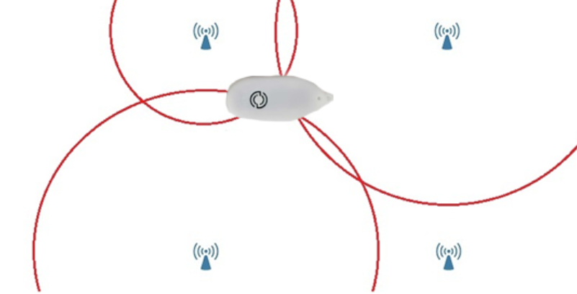
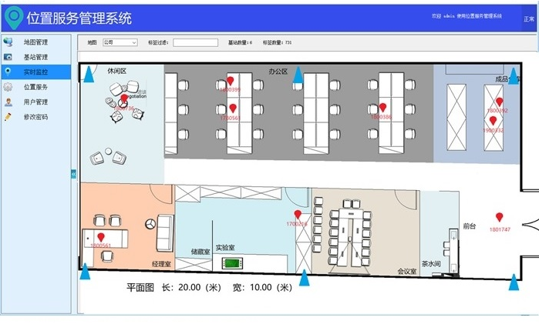

(3) Using a handheld device to locate tags (in the absence of a positioning system)
(1) Simple search operation
- Bind Code:
  - When receiving items into storage, open the Warehouse Elf handheld terminal.
  - Use a handheld device to scan the item barcode; if no item barcode is available, you may arbitrarily create and enter one.
  - Next, scan the QR code or enter the label ID to complete the binding between the item barcode and the label ID.
- seek ：
  - When you need to search for items, reopen the handheld device.
  - By scanning with a handheld device or entering the item's barcode, you can locate all tags associated with that item.
  - Select the sound-and-light calling function; the sound-and-light alert emitted by the WE-T01 active sound-and-light electronic tag will help you quickly locate items.
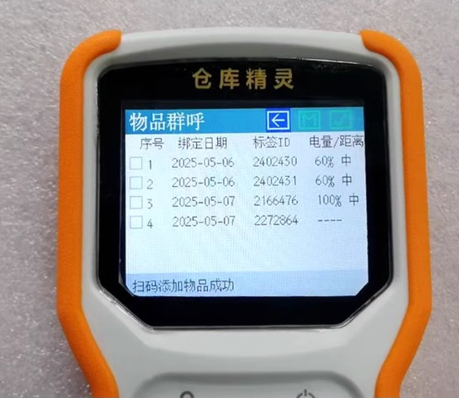
- unbundle ：
  - When items are being discharged from storage, remove the acoustic-optical electronic tag.
  - Use a handheld device to scan the QR code or enter the tag ID to complete the unbinding process; once unbound, the electronic tag can be used for other items.
  - Alternatively, you may skip the unbinding process and directly attach the tag to another item; in this case, the handheld device will prompt you: "This tag is already bound – would you like to automatically unbind it from its current item?" Upon confirmation, the system will automatically complete both the unbinding and re-binding operations.

(2) User Manual for Different Versions
- Simplified Version (Product Model: WE-HS285): Supports only the four operations listed above—binding, unbinding, searching, and inventory counting. To perform these operations, simply use the corresponding function keys or menu options on the handheld device and follow the on-screen prompts.
- Single-machine version (Product model: WE-HS280):
  - Warehouse Management Operations: Install the companion software on your computer; once the software is open, you can create categories and items (by entering the name and specifications).
  - Item inbound and outbound operations: Use a handheld device to scan the item's barcode or enter relevant information, then use the computer software to complete the item's inbound and outbound process.
  - View and call items: The computer software interface allows you to view item information and call items (which triggers a sound and light alert).
- online edition ：
  - Multi-user collaborative management: Multiple users can simultaneously use the web version to jointly manage a warehouse. After installing the free Android app on your standard mobile phone, connect it to a Bluetooth card reader (e.g., WE-BT32).
  - Search operation: Scan the QR code with your mobile phone or enter the item's barcode to initiate the audible and visual search.
  - Data Support: Shidian Technology provides free cloud-based backend data support. If the customer opts for a localized deployment, they may purchase a data server (e.g., WE-LS30). Additionally, this system can be paired with an Android handheld device (e.g., WE-HS230) or a WiFi-enabled Warehouse Wizard handheld device (e.g., WE-HS290).
(4) Implement a Warehouse Management System (developed if necessary)
1. Desktop version: Visit the specified URL to download the Warehouse Management System software, then complete the installation by following the installation wizard.
2. Mobile device: Search for the appropriate warehouse management app in the app store, or download and install it by scanning the specified QR code.
3. Mobile App: Search for the relevant app name in the mobile app store to download and install it.
4. Open the management system and log in using the account and password assigned by the administrator.
5. Based on the actual warehouse layout and management requirements, configure the system with electronic tag information, positioning base station parameters, etc. (if a positioning base station is present).
6. Inventory Count: On the management system interface, select the inventory count function; the system will automatically search for and display all electronic tag information within the warehouse, including ID, location, etc.
7. Calling: In the management system, select the electronic tag you wish to locate, click the call button, and the corresponding electronic tag will immediately emit a sound-and-light alert. You can also perform the calling operation via the corresponding functions of a base station, handheld device, or mobile app.

V. Label Reporting Data
The data transmitted by the tag primarily includes the tag ID, tag type, low-voltage alert, extended data, and other information. For different types of tags, except for "extended data," the format of all other data is identical; for detailed information, please refer to the reader's user manual.
The extended data for this tag consists of a single byte, as detailed below:
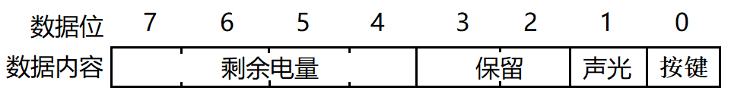
BIT 0: Confirm Button
1: "Confirm Button" is pressed; 0: "Confirm Button" is not pressed.
The user can use this bit to determine whether a button press has occurred on the tag. In practice, the application system uses this flag to verify whether the user has found an item.
BIT 1: Audible and visual warning sign.
1: Sound and light alert is enabled; 0: Sound and light alert is disabled.
Users can use this bit to determine whether the tag has successfully received the audio-visual alert command.
BIT 4–7: Remaining battery charge
numeric value | quantity of electricity
0 | 0%
1 | 10%
2 | 20%
3 | 30%
4 | 40%
5 | 50%
6 | 60%
7 | 70%
8 | 80%
9 | 90%
10 (hexadecimal "A") | 100%

VI. Call Label Data
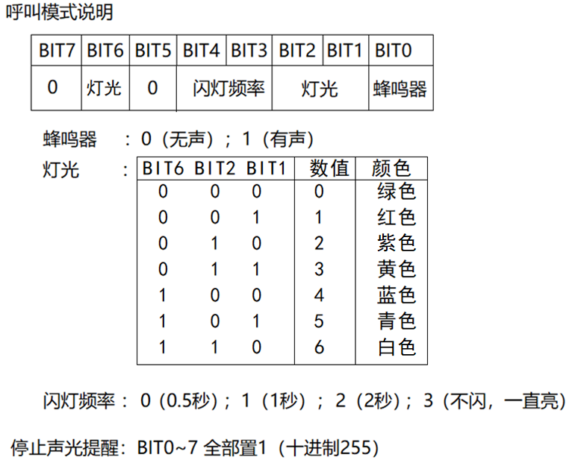

VII. Locate and Confirm Items
After the user locates an item using the audio-visual alert, they can press the confirmation button on the tag; this will immediately stop the audio-visual alert (the tag must have been previously bound to a person or an item name). Additionally, in the next ten wireless reporting transmissions, a "button-pressed" flag will be included. Upon receiving this flag, the application system shall consider that the user has successfully located the tag.

VIII. Precautions
1. Keep dry: Ensure that the label surface remains dry at all times. Exposure to humid environments may allow moisture to penetrate the device interior, adversely affecting the performance of electronic components, leading to data transmission anomalies, failure of the audible and visual alert functions, or other damage. If the label comes into contact with liquid by accident, immediately disconnect the power supply, wait until the label is completely dry, and then attempt to use it again.
2. Keep away from metal: Avoid placing the tag in areas with a high concentration of metal. Metal can interfere with wireless signal transmission, impair the tag's ability to broadcast its ID information, and disrupt communication with devices such as handheld terminals and positioning base stations, potentially leading to inaccurate positioning or failure to locate the tag. Please choose locations far from areas with dense metal objects for installation.
3. Avoid enclosed spaces: Do not place the tag in enclosed spaces. Good air circulation is essential for equipment heat dissipation and wireless signal propagation. Enclosed spaces may cause the device to overheat, shorten battery life, and also obstruct signal transmission, thereby impairing the normal operation of the tag.
4. Keep away from corrosive substances: Do not place the label near any corrosive materials. Corrosive substances may erode the label's casing and internal components, causing irreversible damage that can severely compromise equipment performance and service life. If corrosive substances are detected in the vicinity, relocate the label to a safe location as soon as possible.
5. Adhere to the temperature and humidity range: Please use the label only within the specified operating temperature and humidity conditions. The operating temperature range is-20°C to 70°C, and the operating humidity range is 10%–80%. Operating outside this range may adversely affect various performance aspects of the device, such as battery life, wireless transmission stability, and audio/visual effects; prolonged operation under extreme conditions may also lead to permanent damage to the device.
6. Standardized Maintenance: During maintenance procedures, it is strictly prohibited to arbitrarily modify the parameters, specifications, or model numbers of the product's components. The internal components of the equipment have undergone meticulous matching and calibration; any arbitrary modification may compromise the equipment's electrical performance and functional balance, potentially rendering the equipment unable to operate normally. If the equipment malfunctions, you should contact professional maintenance personnel and follow the instructions in the product's maintenance manual strictly.

IX. Undervoltage Alert Explanation
When the battery level falls below 20%—i.e., when the device is in a low-voltage state—the audio-visual alert function of the electronic tag will make the following adjustments: the tag will be re-called, but no further audio-visual alerts will be issued. At this point, the red light on the electronic tag will flash occasionally to remind you to replace the battery promptly.
Even when operating under low-voltage conditions, the tag will still maintain its wireless transmission functionality. After every 10 transmissions, the red light will flash once, allowing you to visually confirm that the tag is still functioning but has insufficient battery power. During this period, although the tag is under low voltage, it can still perform up to 1 million transmissions, providing you with a certain buffer window to schedule battery replacement.

X. Frequently Asked Questions and Solutions
1. Problem: The electronic tag does not emit light or sound.
Causes: The battery may be completely drained; the LED beads or buzzer may be damaged; or there may be issues with the software settings.
Solution: First, replace the CR2450 battery; then check whether the audio and visual settings in the management system are correct; if the hardware is damaged, contact after-sales service for repair or replacement.
2. Issue: The electronic tag cannot broadcast ID information.
Causes: insufficient battery power, severe signal obstruction at the installation location, or equipment failure.
Solution: Replace the battery; adjust the installation position to a location with a strong signal; if the issue persists, contact after-sales service for repair.
3. Problem: The handheld device cannot locate the tag.
Causes: Possible reasons include incorrect tag ID input, the tag being outside the search range of the handheld device, or an abnormal communication between the handheld device and the tag.
Solution: Carefully verify whether the tag ID has been entered correctly; try using the handheld device to search at different locations to expand the search range; check the handheld device settings and the status of the electronic tag to ensure normal communication between them – if necessary, restart the device or reconfigure the communication parameters.
4. Issue: The management system cannot call the electronic tag.
Causes: network connectivity issues, incorrect system settings, or electronic tag malfunction.
Solution: Check the network connectivity of the device hosting the management system; verify the electronic tag configuration information within the system; try restarting the electronic tag; if the call still fails, contact technical support.

